Software Engineering



Project Title: Admission Portal
Section: BCS-AI (3C)
Submitted to: Dr. Irum
Submitted by:
Umber Gull 3939
Saba Faryal 3891
Ghania Naveed 3658
Samia Azhar 3897

Requirements Gathering

Introduction

This document outlines the requirements for an Admission Management System for a university. The system will be used by university staff to manage the admission process for new students.

Domain Requirements

- The system shall allow university staff to issue admission forms to prospective students.
- The system shall allow prospective students to fill out admission forms, including their personal information, educational background, and contact details.
- The system shall calculate the average percentage of a student based on their matric and inter percentages.
- The system shall allow university staff to view all submitted admission forms.
- The system shall allow university staff to search for admission forms by form number, student name, or CNIC.
- The system shall allow university staff to identify eligible students based on their age and academic performance.
- The system shall allow university staff to generate a merit list of the top eligible students.

Functional Requirements

- Issue Admission Form: University staff shall be able to issue admission forms by entering a student's name, date of birth, and program of interest. The system shall generate a unique form number for each admission form.
- Fill Out Admission Form: Prospective students shall be able to fill out admission forms by entering their personal information, educational background, contact details, matric and inter percentages, and program of interest. The system shall ensure that all required fields are filled out before the form can be submitted.
- Calculate Average Percentage: The system shall automatically calculate the average percentage of a student based on their matric and inter percentages.
- View All Applicants: University staff shall be able to view a list of all submitted admission forms. The list shall display the form number, student name, date of birth, CNIC, phone number, city, house number, street number, program of interest, matric percentage, inter percentage, average percentage, and religion of each student.
- Eligible Students: The system shall identify students who are eligible for admission based on their age (between 18 and 22 years old) and average percentage (above 50%). The system shall display a list of eligible students.
- Ineligible Students: The system shall identify students who are ineligible for admission based on their age or average percentage. The system shall display a list of ineligible students.

Non-Functional Requirements

- The system shall be user-friendly and easy to navigate.
- The system shall be secure and protect the privacy of student data.
- The system shall be reliable and available 24/7.
- The system shall be able to handle a large number of concurrent users.
- The system shall be able to generate reports on student admissions.

Success Criteria

- The system shall be successfully implemented and meet all functional and non-functional requirements.
- The system shall be user-friendly and easy to use for both university staff and prospective students.
- The system shall improve the efficiency and effectiveness of the admission process.
- The system shall generate accurate and reliable reports on student admissions.

Open Issues
- The specific format requirements for the CNIC field are not defined.
- The system does not currently handle the rejection of ineligible students.
This is a basic SRS for the admission management system. The specific requirements may need to be further refined and detailed based on the specific needs of the university.

- Use Case Modelling

Actors: Student, Admin
Requirements:
- Register Student
- View Grades
- Display Enrolled Student
- Search for Student
- Generate Reports
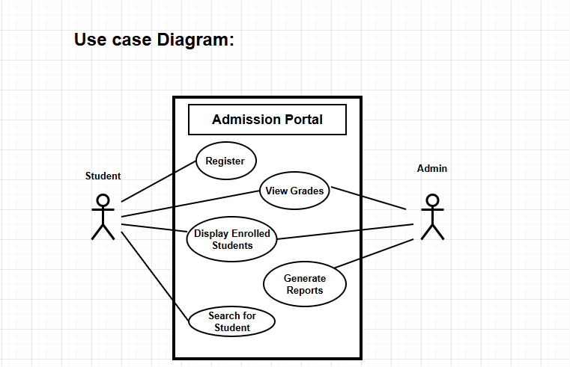

Here is the written use case template for each use case in the diagram:

Use Case 1: Register

1. Use Case Title: Register
2. Primary Actors: Student

3. Preconditions:
- The admission portal must be online and accessible.
- The student must not already have an account.

4. Minimal Guarantee:
- The system will confirm if the registration process cannot be completed due to an error.

5. Success Guarantee:
- The student’s account is successfully created, and they receive login credentials.

6. Trigger:
- The student initiates the registration process by selecting the "Register" option.

7. Extensions:
- E1: If mandatory fields are missing, the system will prompt the student to complete them.
- E2: If the student is already registered, the system will notify them.

Use Case 2: View Grades

1. Use Case Title: View Grades
2. Primary Actors: Student, Admin

3. Preconditions:
- The student or admin must be logged into the system.
- Grades for the relevant courses must be available in the database.

4. Minimal Guarantee:
- The system informs the user if no grades are available.

5. Success Guarantee:
- The user is able to view the grades accurately.

6. Trigger:
- The user selects the "View Grades" option.

7. Extensions:
-E1: If the database is inaccessible, the system notifies the user and provides an option to retry.

Use Case 3: Display Enrolled Students

1. Use Case Title: Display Enrolled Students
2. Primary Actors: Admin
3. Preconditions:
- The admin must be logged into the system.
- The system must have a list of enrolled students.
4. Minimal Guarantee:
- The system will inform the admin if no students are enrolled.

5. Success Guarantee:
- The system displays a list of all currently enrolled students.

6. Trigger:
- The admin selects the "Display Enrolled Students" option.
7. Extensions:
- E1: If the database is down, the system notifies the admin and logs the error.

Use Case 4: Search for Student

1. Use Case Title: Search for Student
2. Primary Actors: Admin
3. Preconditions:
- The admin must be logged into the system.
- The student data must exist in the database.

4. Minimal Guarantee:
- The system will notify the admin if no matching student is found.

5. Success Guarantee:
- The admin is able to retrieve the requested student’s details.

6. Trigger:
- The admin enters the search criteria (e.g., name or student ID).

7. Extensions:
- E1: If the search criteria are invalid, the system prompts the admin to enter valid criteria.

Use Case 5: Generate Reports

1. Use Case Title: Generate Reports
2. Primary Actors: Admin

3. Preconditions:
- The admin must be logged into the system.
- The necessary data must be available in the database.

4. Minimal Guarantee:
- The system notifies the admin if report generation fails.

5. Success Guarantee:
- The system generates and presents the requested reports to the admin.

6. Trigger:
- The admin selects the "Generate Reports" option.

7. Extensions:
E1: If the report criteria are incomplete, the system prompts the admin for additional details.
E2: If the system faces a timeout, the admin is notified and given an option to retry.

- Activity Diagram:

Here’s an activity diagram with Swim Lane notations.

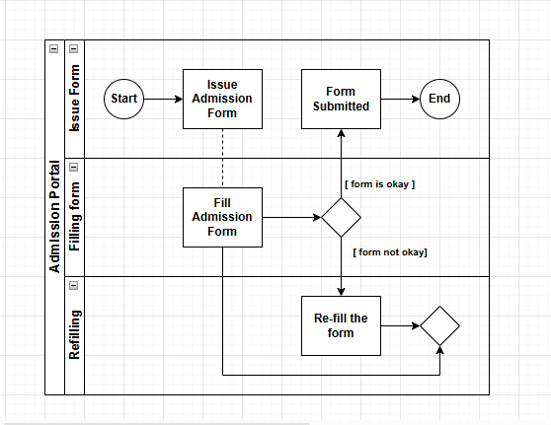

Data flow Diagrams
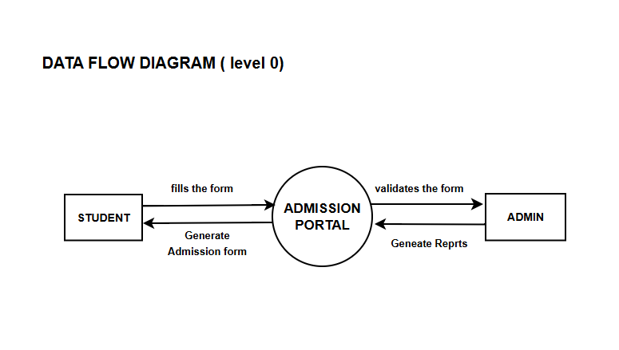
--------------------------------------------------------------------------------------
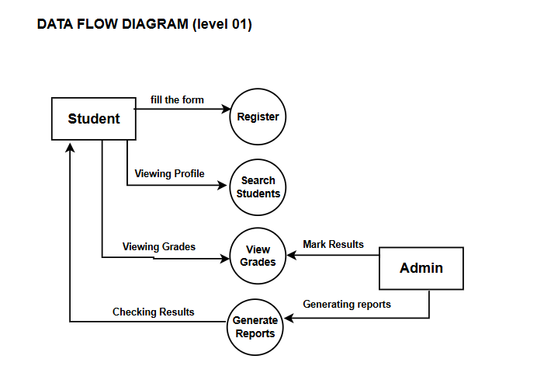

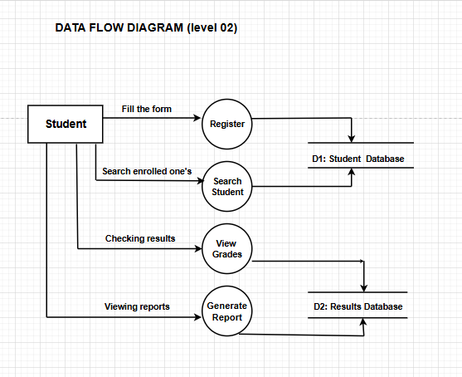

SOW



Statement of Work
Introduction
Name of Project
Admission Portal

Contact | Email/Cell
Sponsor: | umbergull51@gmail.com
Stakeholder: | Sabafaryal89@gmail.com
Project Manager: | ghanianaveed@gmail.com
Team Member: | samiaazhar3@gmail.com
Contractor/Vendor: | aliKhan547@gmal.com

Background
Creating an online admission portal.

Purpose
Allow people to fill up admission form without visiting campus.



Scope of Work
To Be Done | Resources Needed | Outcome | Time Involved | General Steps
Item #1 | Personal data | saved | 2 days | Fill up form
Item #2 | Educational data | reporting | 1 day | Fill up form
Item #3 | Result | Displaying results | 2 days | View results

Location
Site | Duration
Office | 1:30 pm-4:00 pm
Remote Location | 5:00 pm-6:30 pm

Schedule
Phases | Start | Finish
Phase #1 | 2nd Jan, 2025 | 20th Jan, 2025
Phase #2 | 25th Jan, 2025 | 1st March, 2025

Phase #3 | 6th March, 2025 | 8th March, 2025

Free Gantt chart template for Excel

Deliverables
Deliverable | Objective | Due Date
Deliverable #1 | Getting Personal Information | 22nd Jan, 2025
Deliverable #2 | Getting Educational Information | 5th March, 2025
Deliverable #3 | Generating Reports | 7th March, 2025

Milestones
Milestones | Start Date | Finish Date
Milestone #1 | 2nd Jan, 2025 | 22nd Jan, 2025
Milestone #2 | 25th Jan, 2025 | 5th March, 2025
Milestone #3 | 4th March, 2025 | 7th March, 2025

Tasks
Activity | Duration | Team Member
Task #1 | 20 days | Samia , Saba
Task #2 | 10 days | Ghania, Umber
Task #3 | 4 days | Samia, Ghania

Free task tracking template for Excel

Reporting and Communications
This is a console base application which takes personal and educational information form user and according to some constraint proceed or deny the admission of the applicant.

Standards and Testing
Standard/Test | Team Member | Due Date
Standard | Samia, Umber | 2nd Feb, 2025
Test #1 | Ghania, Saba | 4th March, 2025
Test #2 | Umber, Saba | 17th March, 2025

Define Success
If requirements of the admission fulfilled then proceed the admission.

Requirements
Some age and percentage factors are required to map for admission.

Other
Fill the form as directed and provide all the relevant information needed.

Payments
Who | How Much | Payment Due
Vendor #1 | 12,000 | 4th Feb, 2025
Vendor #2 | 7000 | 28th Feb, 2025
Vendor #3 | 8500 | 5th March, 2025



Test Cases:
Here are the test cases based on the given use case diagram for the Admission Portal:

Test Case 1: Register Student

Field | Details
Test Case ID | TC_001
Test Scenario | Verify if a student can successfully register on the portal.
Test Steps | 1. Open the Admission Portal.2. Click on "Register".3. Enter required details (name, email, password, etc.).4. Submit the form.
Prerequisite | Student must not already be registered.
Test Data | Name: John Doe, Email: john@example.com, Password: Password123.
Expected Result | Student registration is successful, and a confirmation message is displayed.
Actual Result | [To be filled after execution].
Environment | Web Browser: Chrome 112, OS: Windows 10.
Comments | Ensure email validation is applied.

Test Case 2: View Grades

Field | Details
Test Case ID | TC_002
Test Scenario | Verify if a student can view their grades.
Test Steps | 1. Login to the Admission Portal.2. Navigate to the "View Grades" section.3. Verify grades are displayed.
Prerequisite | Student must be enrolled and grades must be uploaded by the admin.
Test Data | Username: john@example.com, Password: Password123.
Expected Result | Grades are displayed correctly for the logged-in student.
Actual Result | [To be filled after execution].
Environment | Web Browser: Chrome 112, OS: Windows 10.
Comments | Check for grade accuracy and ensure security to prevent data leakage.

Test Case 3: Display Enrolled Students

Field | Details
Test Case ID | TC_003
Test Scenario | Verify if the admin can view a list of all enrolled students.
Test Steps | 1. Login as admin.2. Navigate to the "Display Enrolled Students" section.3. Verify the list of students is displayed.
Prerequisite | There should be enrolled students in the database.
Test Data | Admin Username: admin@example.com, Password: Admin123.
Expected Result | A complete list of enrolled students is displayed.
Actual Result | [To be filled after execution].
Environment | Web Browser: Firefox 108, OS: Ubuntu 20.04.
Comments | Check for correct data retrieval and performance under large datasets.

Test Case 4: Search for Student

Field | Details
Test Case ID | TC_004
Test Scenario | Verify if admin can search for a student using various filters (e.g., name, ID).
Test Steps | 1. Login as admin.2. Navigate to the "Search for Student" section.3. Enter search criteria (e.g., student name).4. Submit search request.
Prerequisite | Student records must exist in the database.
Test Data | Student Name: John Doe.
Expected Result | The search result displays the correct student record.
Actual Result | [To be filled after execution].
Environment | Web Browser: Edge 115, OS: macOS Monterey.
Comments | Validate search by various fields (e.g., name, ID, email).

Test Case 5: Generate Reports

Field | Details
Test Case ID | TC_005
Test Scenario | Verify if the admin can generate reports on admissions.
Test Steps | 1. Login as admin.2. Navigate to "Generate Reports" section.3. Choose report type (e.g., admission status, enrolled students).4. Submit the request.
Prerequisite | Students must be registered and admissions data must be available.
Test Data | Report Type: Enrolled Students.
Expected Result | Report is generated and displayed/downloaded successfully.
Actual Result | [To be filled after execution].
Environment | Web Browser: Safari 14, OS: iOS 16.
Comments | Ensure report data accuracy and allow exporting options (e.g., CSV, PDF).
These test cases cover all the functionalities depicted in the use case diagram. Let me know if you need them formatted into a document.

